**Spike:** 1

**Title:** Simple Game Loop

**Author:** Parth Madhani , 101901858

**Goals / deliverables:**

* Code
  + Resources.h
  + WorldProcessor.h
  + WorldProcessor.cpp
  + MoveHandler.h
  + MoveHandler.cpp
  + Source.cpp
* Spike Plan
  + Simple paper design.

**Technologies, Tools, and Resources used:**

* Visual Studio IDE
* [www.cplusplus.com](http://www.cplusplus.com)
* Canvas

**Tasks undertaken:**

* Developing a spike plan on paper in order to determine how the program will execute.
* Researching some topics such as 2D array initialization.
* Adding functions step by step while making sure code works.

**What we found out:**

I found out how to implement a simple blocking game loop using the Visual Studio IDE and C++ as the programming language.

I decided to go straight to an object oriented version of this program by ensuring that our plan was designed for this. For the planning I did a rough sequence in order to plan the flow and interactions of the game.

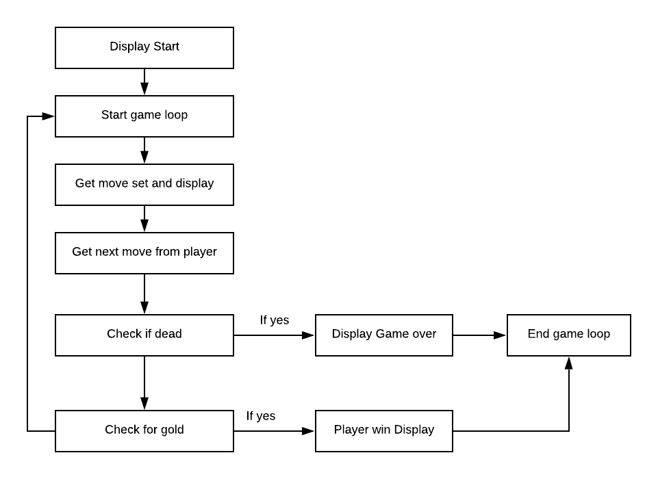

Basically I created a simple program where a array is used to store the basic map of game. I also decided to add a extra wall so as to prevent player from going south during the start of game.

